I.

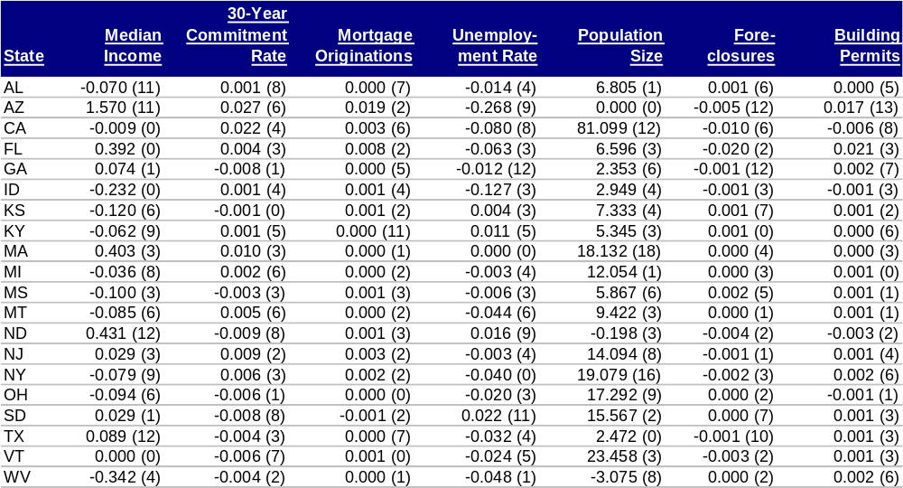
Figure 0.1: Drift Model variable coefficients with the lags in parenthesis ( ) for states

